Task 1:



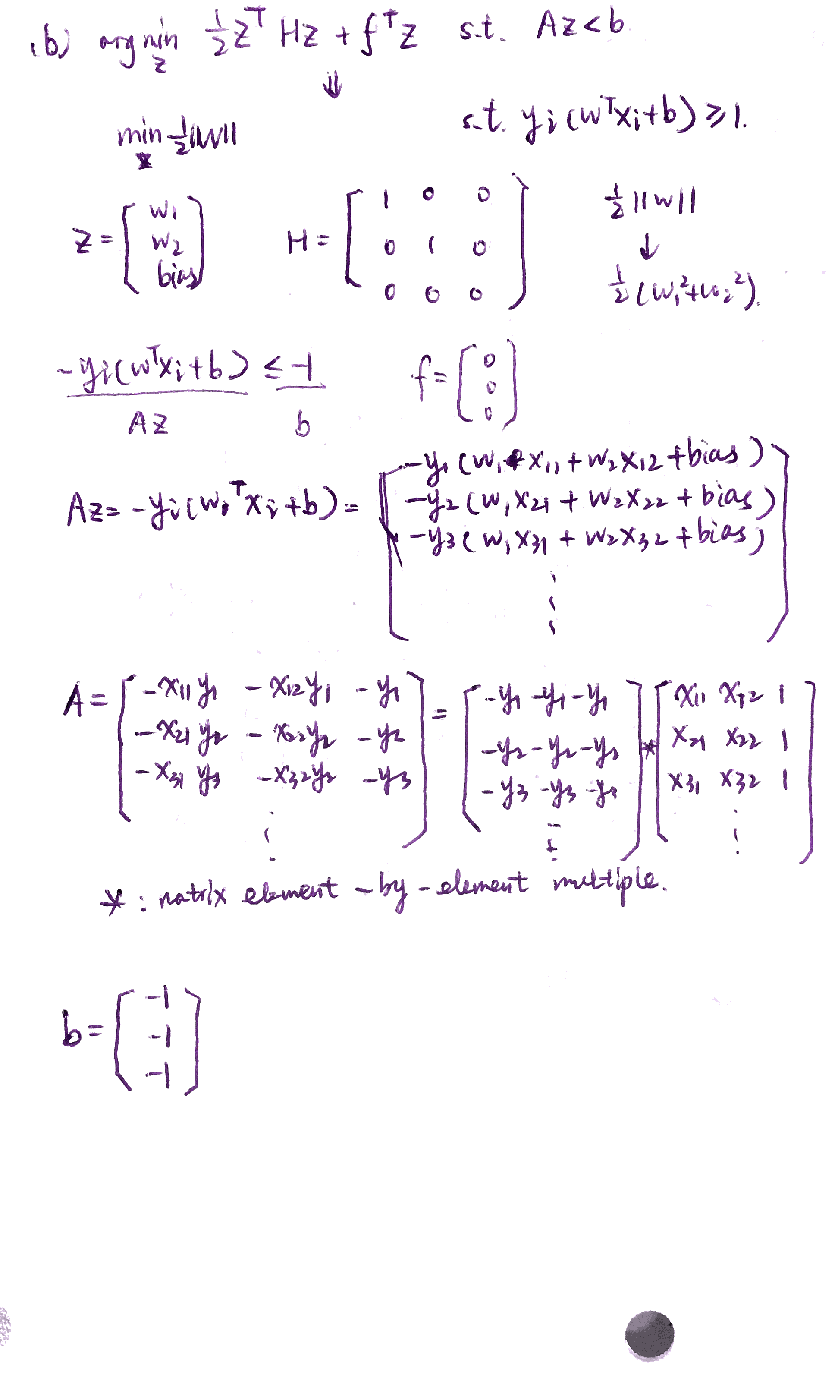

The final optimized values of w and b are:

w1=-6.8339, w2=-6.3831, b=5.4257



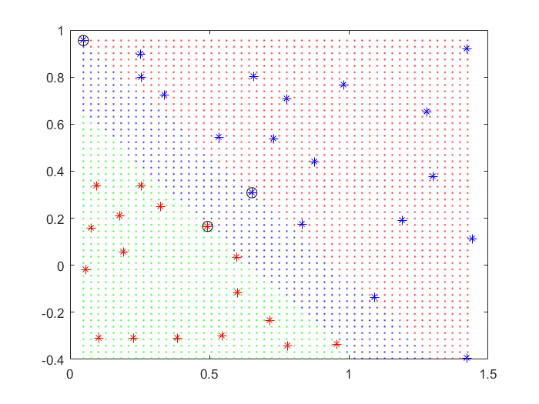

1. exitflag = -2

output =

message: 'No feasible solution found.…'

algorithm: 'interior-point-convex'

firstorderopt: 3.7526e+08

constrviolation: 8.6838

iterations: 9

cgiterations: []

Task 2:

1. 

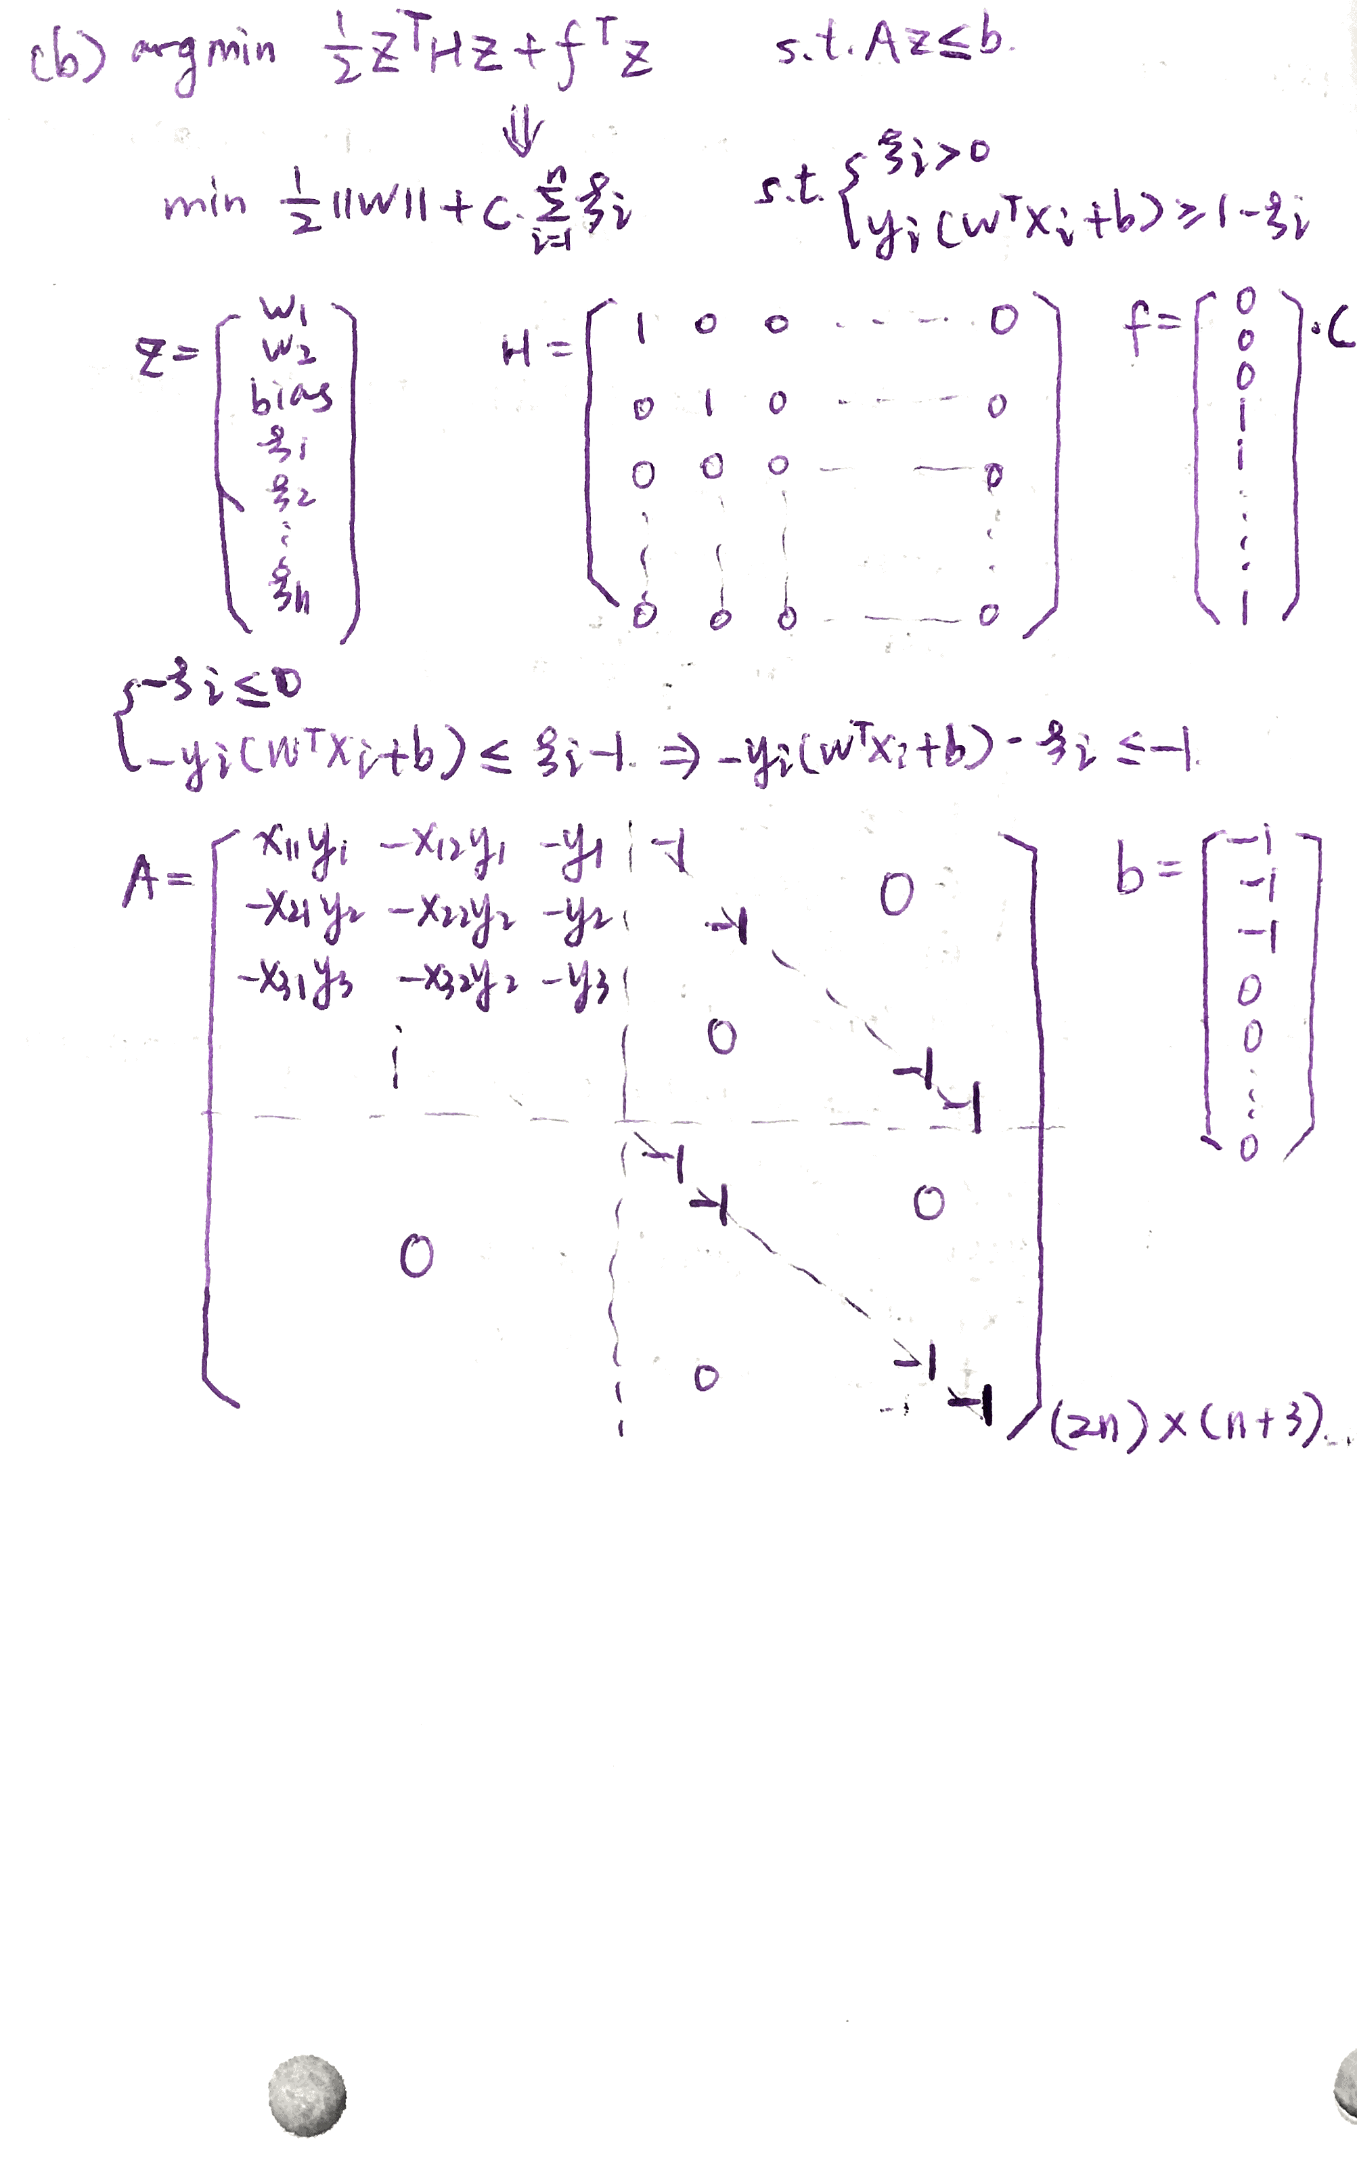

For C=1,

weight = 0.2899 -0.1873

bias = -1.1899

1. Five figures:

